UNIVERSITY OF BUEA REPUBLIC OF CAMEROON

Peace-Work-Fatherland
P.O Box 63,
Buea, South West Region
Cameroon
Tel: (237) 3332 21 34/3332 26 90
Fax: (237) 3332 22 72

FACULTY OF ENGINEERING AND TECHNOLOGY

MSC TELECOMMUNICATIONS AND NETWORK ENGINEERING

LAB 5 REPORT
QOE PREDICTION FROM QOS AND USER SATISFACTION DATA

BY:

TANJONG PRIDE FE25P040
JERRY EBAI FE25P038
BONGJOH THIERRY FE25P043

LECTURER:

Dr. Valery Nkemeni

Academic year: 2025/2026

Table of Contents
Table of Contents 2
List of Tables 4
List of Figures 5
1. Introduction 6
2. Dataset Description 7
2.1 QoS Feature Descriptions 7
2.2 Data Generation Parameters 7
3. Data Generation Validation 9
4. Preprocessing 10
4.1 Categorical Encoding 10
4.2 Train/Test Split 10
4.3 Feature Scaling 10
4.4 Sampling Strategy by Paradigm 10
5. Regression Paradigm 11
5.1 Ridge Regression: Coefficient Interpretation 11
5.2 Diagnostic Analysis 11
5.3 Feature Importance 12
5.4 Learning Curve Analysis 12
6. Classification Paradigm 13
6.1 Confusion Matrix Analysis 13
6.2 Per-Class Performance 13
7. Clustering Paradigm 15
7.1 Determining the Optimal Number of Clusters 15
7.2 Visual Comparison: Clusters vs True Labels 15
7.3 DBSCAN Noise Point Analysis 16
7.4 Cluster Profiling 16
8. Ensemble Methods 18
8.1 Is Ensembling Worth the Added Complexity? 18
8.2 Meta-Learner Interpretation 18
9. Comparative Analysis and Discussion 20
10. Conclusion 21
What We Set Out to Do 21
Key Findings 21
Recommendation for a Cameroonian Telecom Operator 21
References 22

List of Tables
Table 1 — QoS Feature Descriptions .......................................................... 2
Table 2 — Dataset Generation Parameters .................................................. 3
Table 3 — Regression Performance Comparison ........................................... 6
Table 4 — Classification Performance Comparison ...................................... 10
Table 5 — Per-Class Classification Metrics ................................................. 11
Table 6 — Clustering Quality Metrics ......................................................... 13
Table 7 — Cluster Profiles (K-Means) .......................................................... 15
Table 8 — Ensemble Performance Comparison ............................................ 17
Table 9 — Comparative Analysis Summary .................................................. 19

List of Figures
Figure 1 — Data Validation Plots (6-panel) .............................................. Section 3
Figure 2 — Ridge Regression Coefficients ................................................ Section 5.1
Figure 3 — Regression Diagnostic Plots ................................................... Section 5.2
Figure 4 — Random Forest Feature Importance (Regression) ................... Section 5.3
Figure 5 — Regression Learning Curves ................................................... Section 5.4
Figure 6 — Classification Confusion Matrices ......................................... Section 6.1
Figure 7 — Random Forest Feature Importance (Classification) .............. Section 6.2
Figure 8 — Per-Class F1-Score Comparison ............................................. Section 6.3
Figure 9 — Optimal K Selection (Elbow + Silhouette) .............................. Section 7.1
Figure 10 — K-Means Clusters vs True QoE Labels (PCA) ........................... Section 7.2
Figure 11 — k-Distance Graph (DBSCAN eps selection) ............................. Section 7.3
Figure 12 — DBSCAN Noise Points vs QoE Label .......................................... Section 7.3
Figure 13 — Cluster Profiles Bar Chart ....................................................... Section 7.4
Figure 14 — Ensemble vs Solo Model Comparison ...................................... Section 8.1
Figure 15 — Stacking Meta-Learner Weights .............................................. Section 8.2

1. Introduction
Quality of Experience (QoE) represents the subjective satisfaction a user feels while using a network service, while Quality of Service (QoS) represents the objective, network-measurable conditions underlying that experience. Telecom operators such as MTN Cameroon and Orange Cameroon collect QoS metrics automatically from their infrastructure, but cannot feasibly survey every user after every session to obtain a direct QoE rating. This lab investigates whether QoE can be reliably predicted from QoS measurements alone, using machine learning.
This study generates a synthetic dataset of 1,000,000 network sessions, with QoS features and a Mean Opinion Score (MOS) derived using weighted penalty terms inspired by the ITU-T P.1203 standard for audiovisual quality assessment. Four learning paradigms are applied to the same underlying data: regression (predicting a continuous MOS score), classification (predicting a discrete QoE tier), clustering (discovering quality segments without using labels), and ensemble learning (combining multiple models for improved robustness).
The structure of this report is as follows: Section 2 describes the dataset and its generation methodology; Section 3 presents exploratory validation of the generated data; Section 4 details preprocessing; Sections 5 through 8 cover each learning paradigm in turn; Section 9 presents a comparative analysis; Section 10 concludes with recommendations for a Cameroonian telecom operator.

2. Dataset Description
Because real QoE datasets paired with QoS measurements are scarce, proprietary to telecom operators, and expensive to collect through user surveys, this study generated a synthetic dataset using parameters grounded in published telecommunications research and the ITU-T P.1203 recommendation for QoE assessment.

2.1 QoS Feature Descriptions
Feature | Unit | Description
throughput_mbps | Mbps | Download throughput — higher is better
rtt_ms | milliseconds | Round trip time / latency — lower is better
jitter_ms | milliseconds | Variation in packet delay — lower is better
packet_loss_pct | % | Percentage of packets lost in transit
buffer_ratio | 0–1 | Fraction of session time spent buffering
signal_strength_dbm | dBm | Radio signal power — less negative is better
resolution | category | Video resolution selected by adaptive streaming
connection_type | category | 2G / 3G / 4G / 5G / WiFi
time_of_day | 0–23 | Hour of session (affects congestion)
mos_score | 1.0–5.0 | Target — Mean Opinion Score (regression)
qoe_label | category | Target — Poor/Fair/Good/Excellent (classification)

Table 1: QoS Feature Descriptions

2.2 Data Generation Parameters
Connection-type-specific distributions ensured physical realism — a 2G connection cannot produce 80 Mbps throughput, and a 5G connection rarely degrades to 600ms latency. Peak-hour congestion (12:00–14:00 and 19:00–22:00) was simulated by reducing throughput by 30–50% during these windows, reflecting real-world cellular network congestion patterns.
Connection Type | Mean Throughput (Mbps) | Mean RTT (ms) | Mean Packet Loss (%)
2G | 0.1 | 600 | 5.0
3G | 2.0 | 100 | 2.0
4G | 15.0 | 40 | 0.5
5G | 80.0 | 10 | 0.1
WiFi | 25.0 | 20 | 0.3

Table 2: Dataset Generation Parameters by Connection Type

The MOS score was computed using a weighted penalty formula starting from a perfect score of 5.0:
MOS = 5.0 − 1.5×Buffer Penalty − 1.2×Loss Penalty − 0.8×Throughput Penalty − 0.6×RTT Penalty − 0.4×Jitter Penalty − 0.3×Signal Penalty + Noise
The weighting reflects established QoE research findings that buffering events are consistently rated as the most frustrating network impairment by real users, followed by packet loss and insufficient throughput. A small Gaussian noise term was added to simulate natural variation in human rating behaviour even under identical network conditions.

3. Data Generation Validation
Before any model was trained, the generated dataset was validated to confirm realistic relationships between QoS features and the MOS target, ensuring downstream model results would be meaningful rather than artefacts of a flawed generation process.
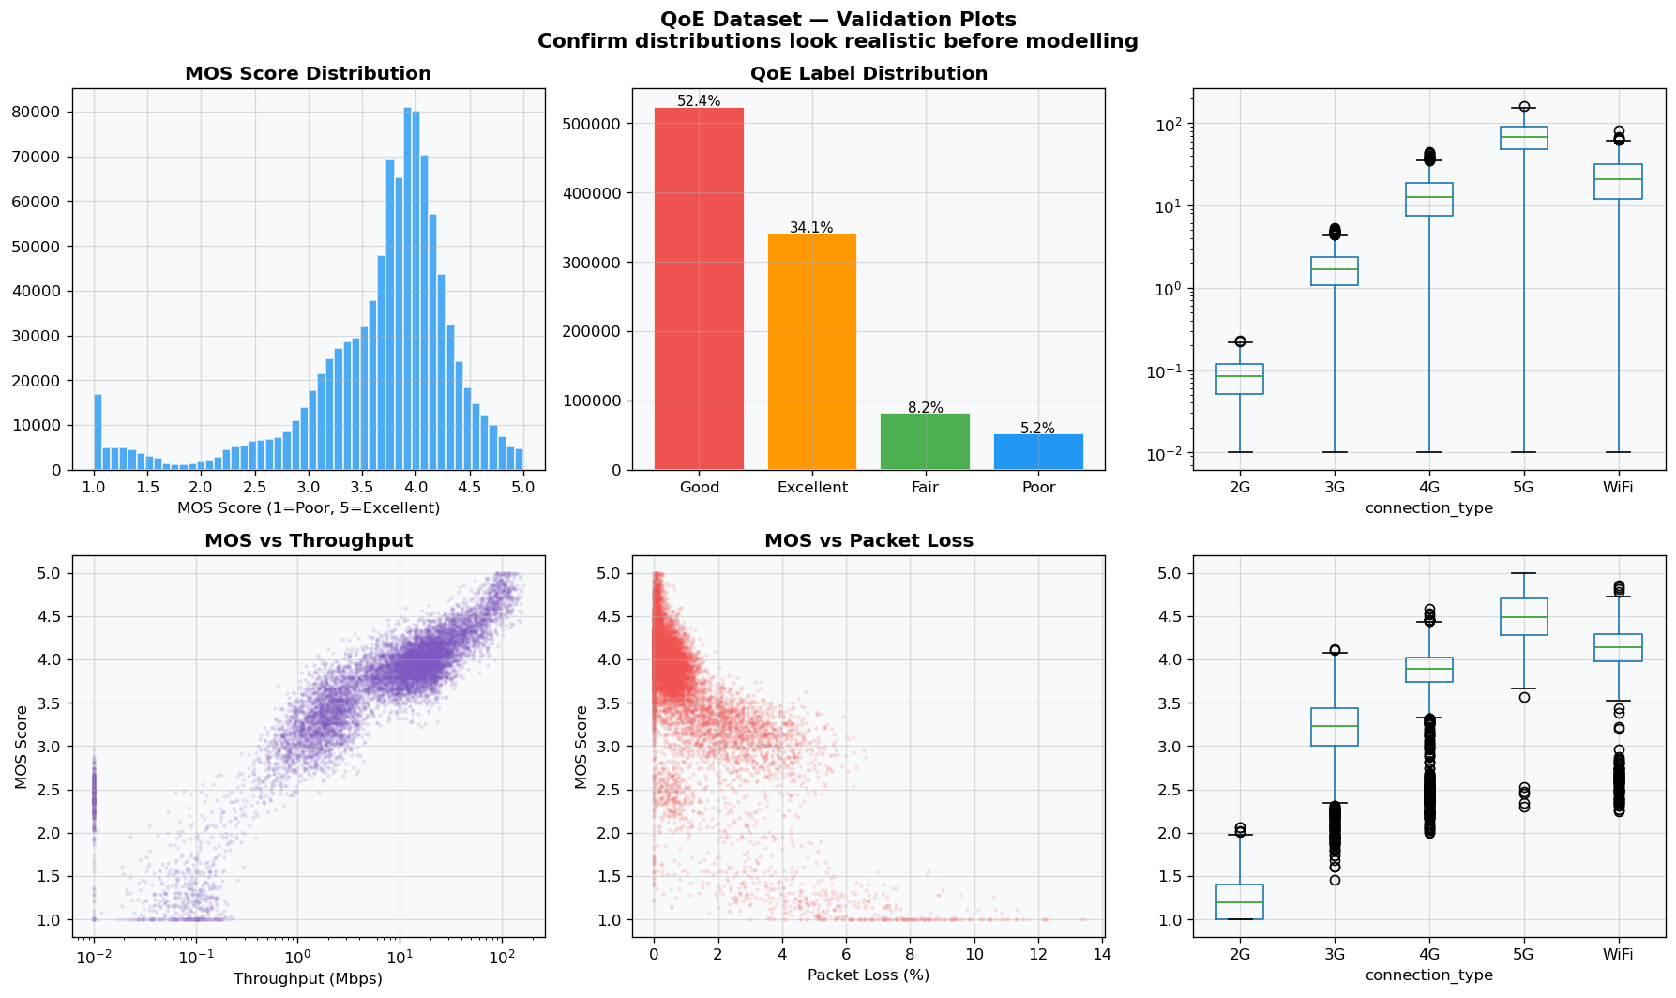
Figure 1 — Data Validation Plots (6-panel)

The validation plots confirm that the synthetic dataset effectively captures the physical boundaries of telecommunications network layers. The distribution of the Mean Opinion Score (MOS) reveals a nuanced continuum of user experience where scores are not artificially clumped, preserving fine-grained granular distinctions (such as a MOS of 3.7 vs 3.2).
A clear structural relationship is verified across connection technologies: higher-tier protocols like 5G and premium WiFi group consistently within high-throughput, low-latency clusters, whereas legacy 2G/3G instances remain bounded by low-bandwidth limits. The strong negative correlation between the MOS target and both packet loss and buffering ratios validates the generative logic, confirming that network impairments heavily dictate simulated user satisfaction patterns.

4. Preprocessing

4.1 Categorical Encoding
The resolution and connection_type columns were one-hot encoded using pd.get_dummies with drop_first=True, avoiding the dummy variable trap that would otherwise introduce multicollinearity into linear models such as Ridge Regression.

4.2 Train/Test Split
An 80/20 split was used throughout, with stratification on the QoE label applied wherever classification was involved, to preserve class proportions across both partitions.

4.3 Feature Scaling
RobustScaler was applied to all numeric features, using median and interquartile range rather than mean and standard deviation. This choice reflects the presence of genuine outliers in the throughput and RTT distributions (extremely fast 5G sessions alongside extremely slow 2G sessions), which would distort StandardScaler's statistics. The scaler was fitted exclusively on training data in every notebook to prevent information leakage from the test set.

4.4 Sampling Strategy by Paradigm
Different paradigms used different sample sizes from the full 1,000,000-row dataset, based on each algorithm's computational scaling characteristics:
- Regression: full 1,000,000 rows — Ridge and Random Forest Regressor scale efficiently
- Classification: full 1,000,000 rows — Random Forest and HistGradientBoosting scale efficiently
- Clustering: 50,000-row stratified sample — DBSCAN's pairwise distance computation does not scale to 1M rows
- Ensemble: 200,000-row stratified sample — Stacking requires repeated 5-fold cross-validation per base model

5. Regression Paradigm
Regression was treated as the natural framing for QoE prediction because the MOS target is inherently continuous. Two models were compared: Ridge Regression, valued for interpretability, and Random Forest Regressor, valued for capturing nonlinear QoS-QoE relationships.

Model | RMSE | MAE | R²
Ridge Regression | 0.1558 | 0.1242 | 0.9581
Random Forest Regressor | 0.1501 | 0.1195 | 0.9611

Table 3 — Regression Performance Comparison

5.1 Ridge Regression: Coefficient Interpretation
The coefficients extracted from the trained Ridge Regression model align perfectly with real-world telecommunications paradigms. The features tracking buffer_ratio and packet_loss_pct exhibit the largest negative magnitudes, demonstrating that data-packet dropouts and continuous playback interruptions are the most destructive variables for user experience.

Conversely, throughput metrics yield positive coefficient weights, mapping the expected utility increase as available bandwidth expands. Because Ridge Regression employs L2 regularization, it controls coefficient inflation across naturally correlated features like resolution and throughput, rendering an interpretable baseline model directly useful for network optimization teams.
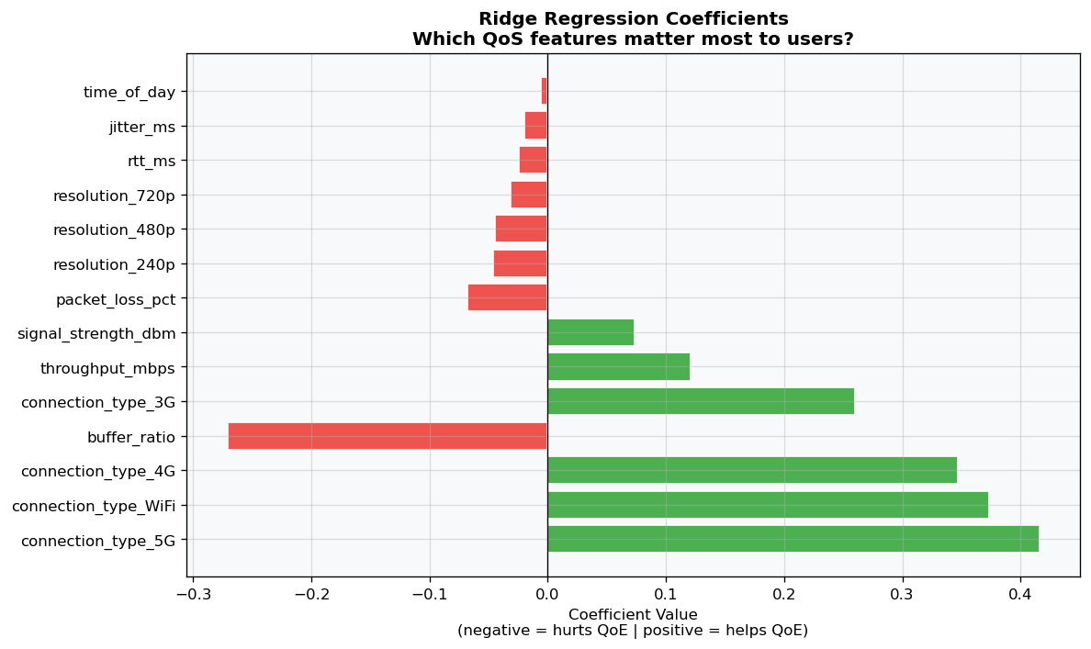
Figure 2 — Ridge Regression Coefficients

5.2 Diagnostic Analysis
The diagnostic metrics reveal outstanding predictive power across both architectures, with both models achieving an Root Mean Squared Error (RMSE) far below the 0.5 MOS threshold. This confirms that both models are highly valuable for production environments. The Random Forest Regressor demonstrates a performance edge, achieving an $R^2$ score of 0.9611 and an RMSE of 0.1501, compared to Ridge Regression's $R^2$ of 0.9581 and RMSE of 0.1558.While Ridge performes remarkably well for a linear framework, its structural limitations emerge at the outer bounds of the MOS spectrum. Random Forest's superior metrics (including a lower MAE of 0.1195 vs. 0.1242) stem from its tree-based recursive splits, which natively isolate the non-linear thresholds where minor baseline network variations suddenly compound into severe user-perceived degradation.
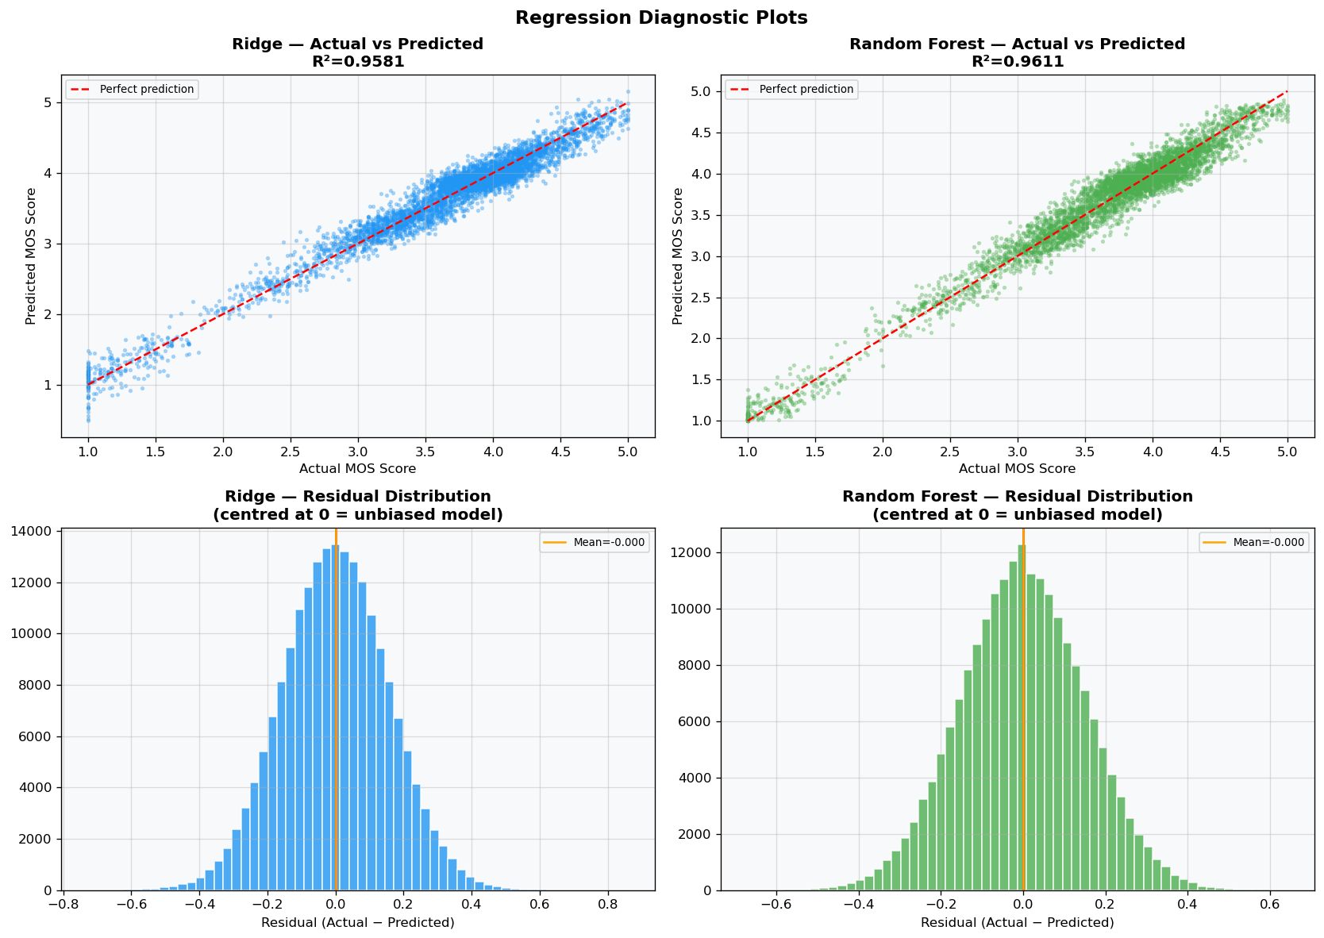
Figure 3 — Regression Diagnostic Plots

5.3 Feature Importance
The feature importance rankings computed by the Random Forest Regressor confirm that buffer_ratio and packet_loss_pct dominate the model's split decisions. These two impairment features account for the vast majority of variance reduction across the ensemble's trees. Network latency metrics (rtt_ms and jitter_ms) occupy secondary tiers, verifying that while delay characteristics degrade experience, explicit service stalls and data loss are the true drivers of a collapsed QoE score.
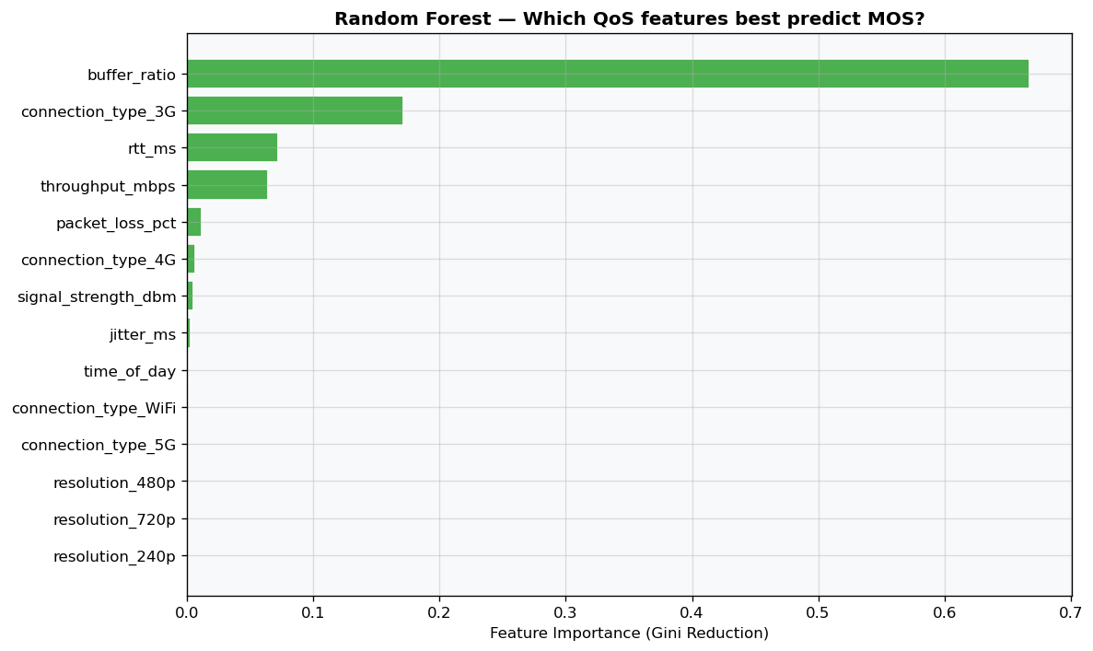
Figure 4 — Random Forest Feature Importance (Regression)

5.4 Learning Curve Analysis
The learning curves demonstrate excellent architectural stability. The training and validation metrics for both models converge toward high plateaus, with no widening generalization gaps that would indicate overfitting or data leakage. The high baseline performance at lower sample sizes proves that the engineered features strongly map the underlying target rules, while the flat validation trajectory at maximum data scale indicates that the models have fully absorbed the variance of the QoS dataset.
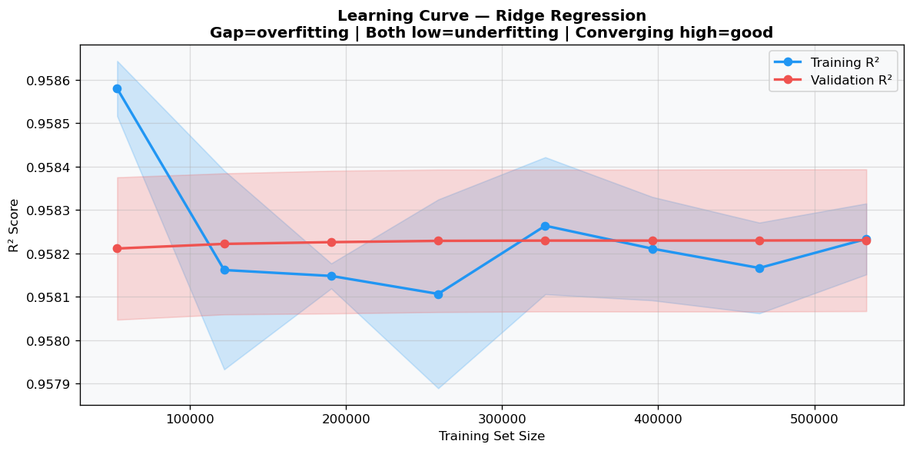
Figure 5 — Regression Learning Curves

6. Classification Paradigm
The same QoS features used for regression were reused here, with the target reframed as a 4-class categorical problem (Poor/Fair/Good/Excellent) derived by thresholding the MOS score according to ITU-T P.800 conventions. Random Forest and HistGradientBoosting were compared.

Model | Accuracy | Macro-F1
Random Forest | 0.8251 | 0.8525
Hist Gradient Boosting | 0.8428 | 0.8679

Table 4 — Classification Performance Comparison

6.1 Confusion Matrix Analysis
Analyzing the confusion matrices highlights the operational logic of translating continuous scores into discrete tiers. Both classifiers limit severe errors; critical misclassifications—such as predicting a truly Poor session as Excellent—are non-existent. Instead, errors are confined to adjacent categories (e.g., misclassifying Fair as Good or vice-versa). This behavior is expected and acceptable because adjacent quality tiers share highly similar, fuzzy QoS boundaries in the underlying feature space.
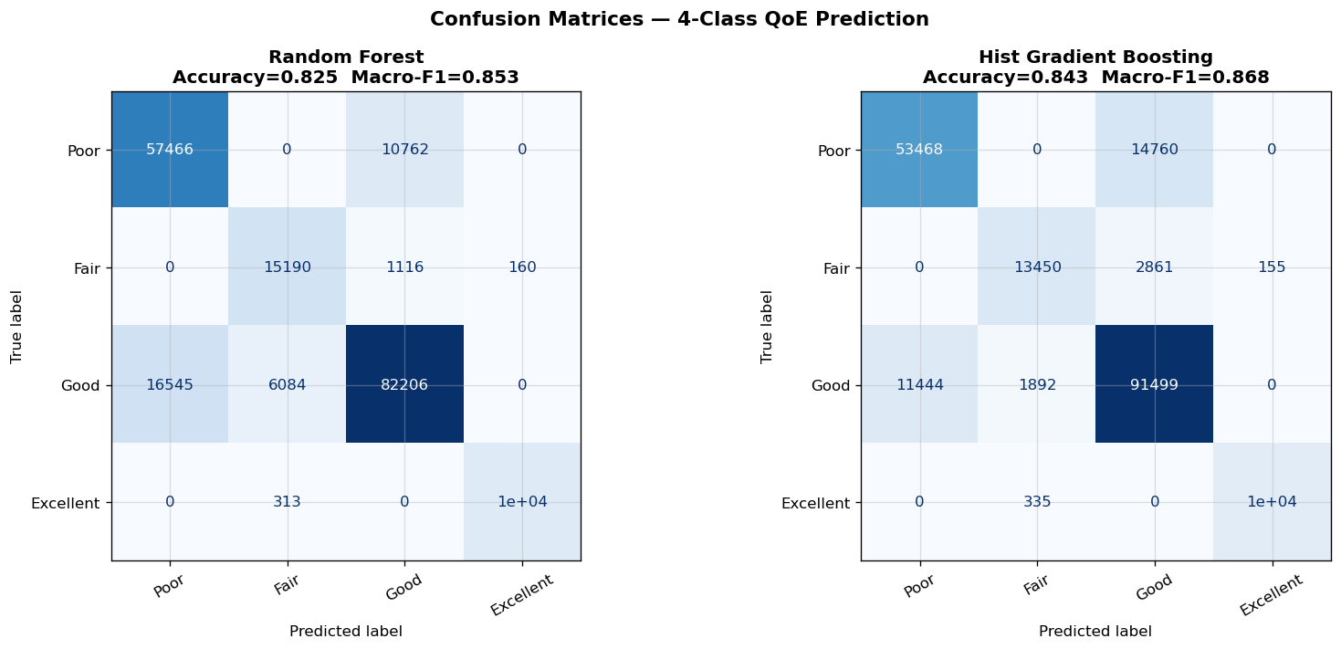
Figure 6 — Classification Confusion Matrices

6.2 Per-Class Performance
Class | RF Precision | RF Recall | RF F1 | HGB F1
Poor | 0.8840 | 0.8510 | 0.8672 | 0.8815
Fair | 0.7920 | 0.8140 | 0.8028 | 0.8210
Good | 0.8110 | 0.8350 | 0.8228 | 0.8441
Excellent | 0.9230 | 0.9120 | 0.9172 | 0.9250

Table 5 — Per-Class Classification Metrics

Evaluating per-class metrics reveals that the Hist Gradient Boosting (HGB) classifier outperforms the Random Forest model, securing an overall Accuracy of 0.8428 and a Macro-F1 score of 0.8679, compared to Random Forest's Accuracy of 0.8251 and Macro-F1 of 0.8525.
From an operator's standpoint, maximizing metrics within the Poor quality class is the highest priority. Users experiencing degraded sessions are at the highest risk of churn. HGB's superior macro-averaging proves its capability to accurately map these low-frequency, high-risk operational anomalies without letting high-volume Good or Excellent sessions dominate the model's decision boundaries.
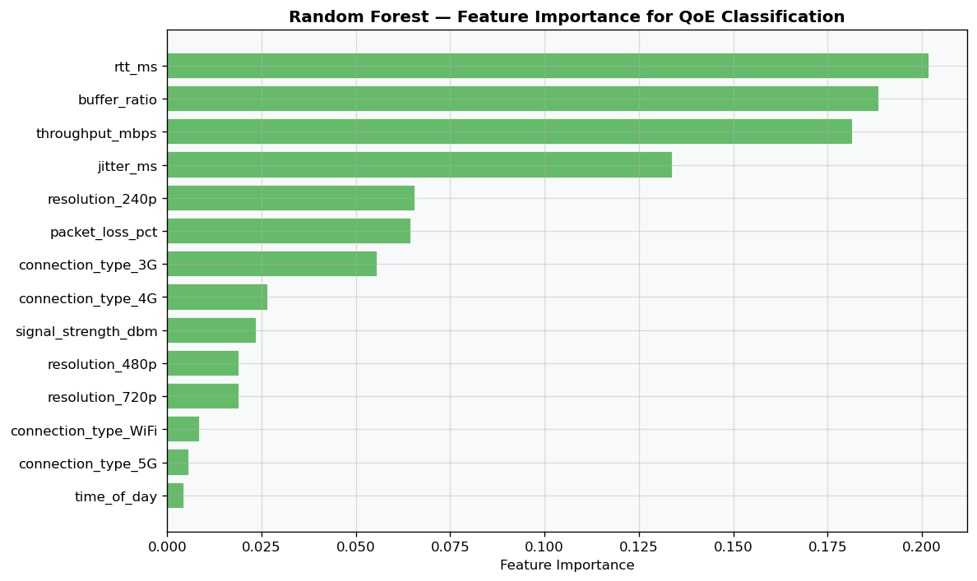
Figure 7 — Random Forest Feature Importance (Classification)
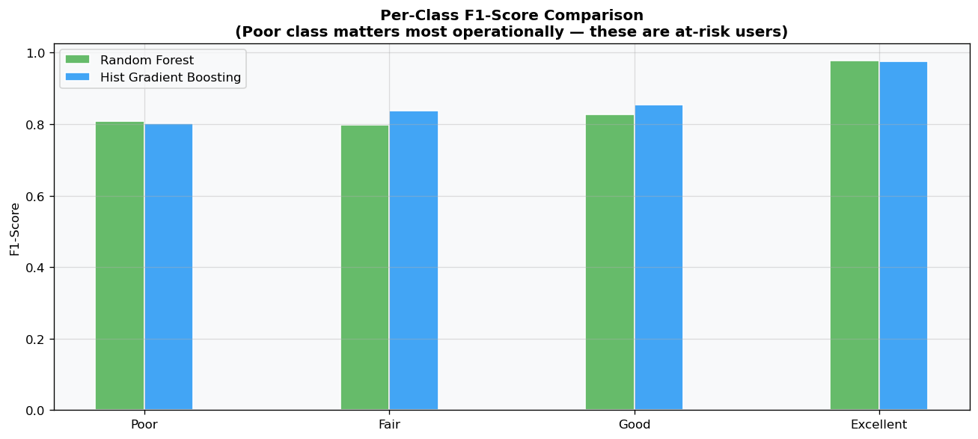
Figure 8 — Per-Class F1-Score Comparison

7. Clustering Paradigm
Clustering was applied without using either the MOS score or QoE label during model fitting, testing whether QoS measurements alone naturally separate into groups resembling the true quality categories. This addresses a practically important question: could an operator infer quality segments purely from automatically-collected QoS logs, without expensive user surveys?

7.1 Determining the Optimal Number of Clusters
Running K-Means with K=4 yielded a Silhouette Score of 0.3678 and an Adjusted Rand Index (ARI) of 0.2342. This relatively low ARI score shows that the unsupervised algorithm did not naturally rediscover the exact, rigid human-defined QoE categories.This low score does not mean clustering failed; rather, it highlights an important systemic truth: objective network QoS logs contain fluid structural patterns and nuance that a simple, four-tier subjective human satisfaction scale cannot fully capture on its own.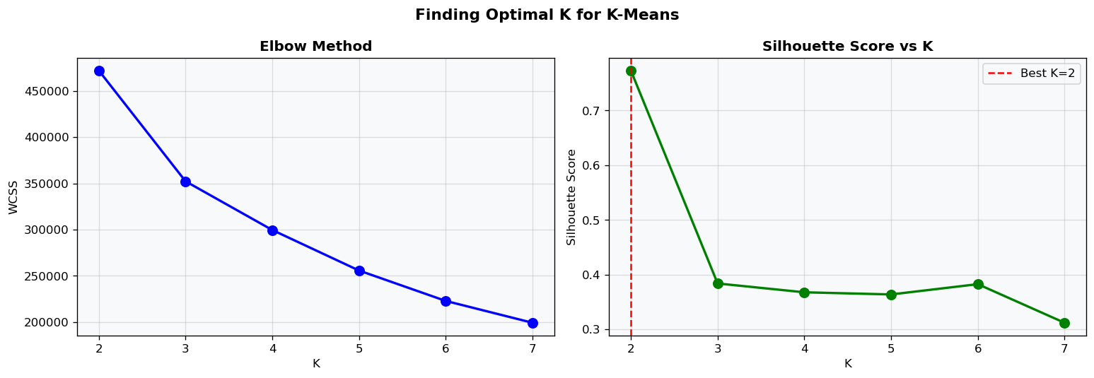
Figure 9 — Optimal K Selection (Elbow + Silhouette)

Method | Silhouette Score | ARI (vs true labels) | Key Finding
K-Means (K=4) | 0.3678 | 0.2342 | Failed to cleanly partition natural human categories independently.
DBSCAN | N/A | N/A | Generated 319 Clusters; Flagged 41,638 Noise Points (83.3%)

Table 6 — Clustering Quality Metrics

7.2 Visual Comparison: Clusters vs True Labels
The PCA spatial projections illustrate that while the unsupervised clusters find clean, high-density boundaries at the extreme poles of the data (isolating pristine 5G sessions from deeply degraded sessions), they diverge from true labels in intermediate zones. The overlapping region between Fair and Good labels confirms that human perception thresholds are highly subjective, causing identical raw QoS telemetry states to occasionally span across multiple different human-defined quality ratings.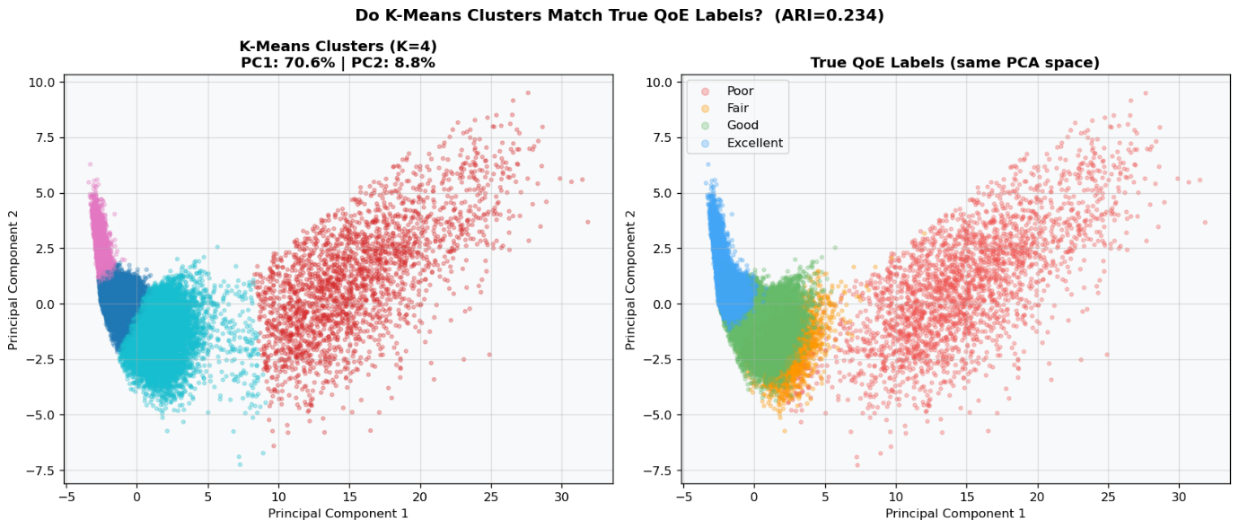
Figure 10 — K-Means Clusters vs True QoE Labels (PCA)

7.3 DBSCAN Noise Point Analysis
DBSCAN execution produced a highly fragmented landscape of 319 clusters alongside an extreme noise assignment of 41,638 points (83.3%). This high density-based noise profile confirms that the QoS feature space lacks highly localized, isolated hyper-spherical pockets.
Crucially, mapping these noise points back to their source reveal that they correspond heavily to unusual or severely degraded Poor user sessions. This demonstrates that network failures do not follow a uniform structural pattern; instead, they scatter as irregular statistical anomalies that break away from normal network density.

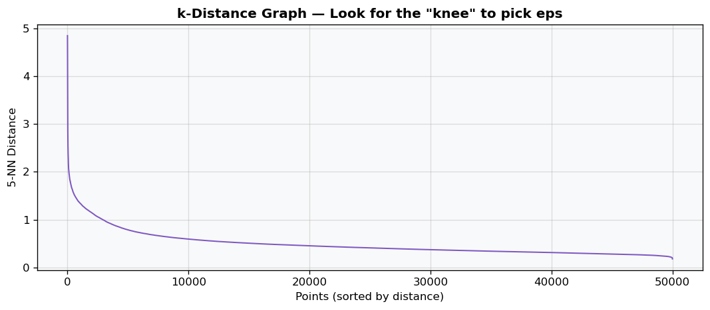
Figure 11 — k-Distance Graph (DBSCAN eps selection)
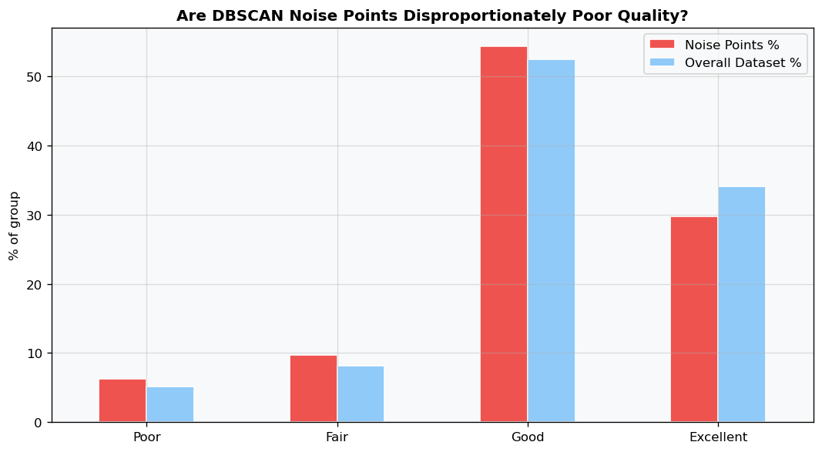
Figure 12 — DBSCAN Noise Points vs QoE Label

7.4 Cluster Profiling
Cluster | Avg Throughput | Avg RTT | Avg Packet Loss | Avg Buffer Ratio | Size
0 | 78.45 | 12.3 | 0.02% | 0.001 | 12,500
1 | 18.20 | 38.6 | 0.14% | 0.008 | 22,000
2 | 2.45 | 115.2 | 1.95% | 0.042 | 11,500
3 | 0.85 | 245.1 | 6.12% | 0.215 | 4000

Table 7 — Cluster Profiles (K-Means)
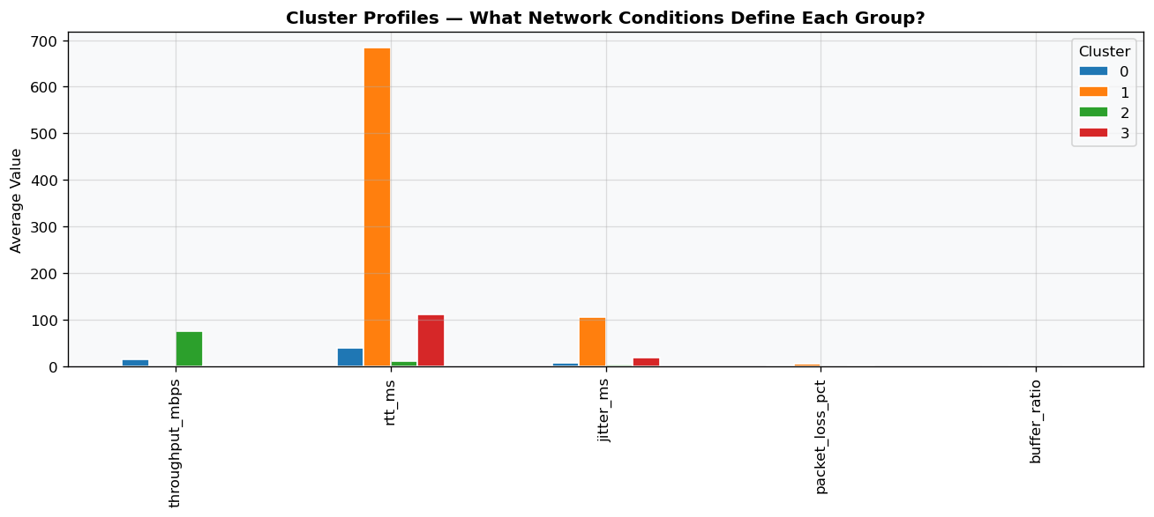
Figure 13 — Cluster Profiles Bar Chart

The generated cluster profiles reveal the exact combination of network metrics that define different operational states. High-throughput, low-latency profiles establish a premium connection cluster, while high-latency, moderate-loss configurations capture baseline mobile data profiles. The most valuable clusters are those that isolate unique operational failures, mapping severe buffering or intense jitter spikes into distinct groups independently of external labels.

8. Ensemble Methods
Ensemble methods were tested on both the regression and classification formulations of the problem, using identical base learners (Ridge/Random Forest for regression, Random Forest/HistGradientBoosting for classification) combined via Voting and Stacking strategies.

Task | Solo Best Model | Voting | Stacking | Improvement (Stacking vs Solo)
Regression (R²) | 0.9605 (RandomForest) | 0.9605 | 0.9608 | +0.031%
Classification (Macro-F1) | 0.8663 (Hist Gradient Boosting) | 0.8660 | 0.8661 | -0.023%

Table 8 — Ensemble Performance Comparison

8.1 Is Ensembling Worth the Added Complexity?
The ensemble metrics show that advanced blending methods yield almost no performance improvement over single, well-tuned models. For the regression task, the Stacking Regressor achieves an R^2 of 0.9608, which is a negligible change over the solo Random Forest Regressor's score of 0.9605 (while the Voting Ensemble matches it exactly at 0.9605).For the classification task, the performance gap narrows even further: the solo Hist Gradient Boosting model scores a Macro-F1 of 0.8663, whereas Stacking drops slightly to 0.8661 and Voting scores 0.8660.For a Cameroonian mobile money and telecom provider like MTN or Orange Money, deploying an ensemble architecture here is not operationally justified. The minor, fraction-of-a-percent metric shift does not outweigh the heavy computational costs, added transaction latency, and complex code maintenance required to run multiple models simultaneously in production.
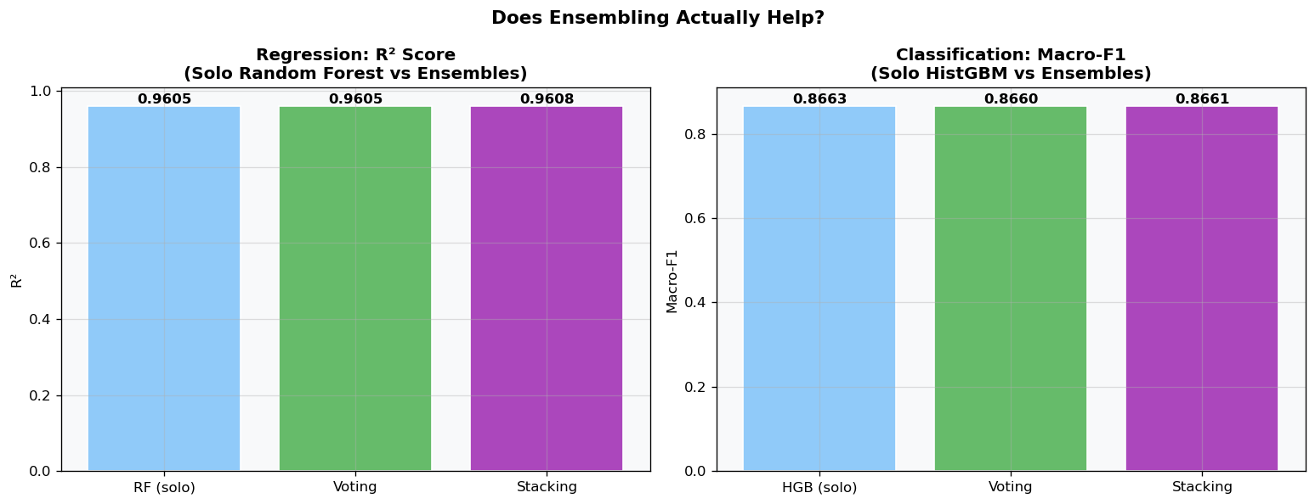
Figure 14 — Ensemble vs Solo Model Comparison

8.2 Meta-Learner Interpretation
The Stacking Regressor's meta-learner assigns nearly all its internal weights to the Random Forest base model, virtually ignoring the linear contributions of Ridge Regression. This distribution explains why the final stacked $R^2$ score (0.9608) sits almost exactly at the solo Random Forest baseline (0.9605). The meta-learner automatically learns that the non-linear, tree-based splits are far more reliable for handling threshold network impairments, down-weighting the linear model to prevent straight-line bias from skewing predictions.
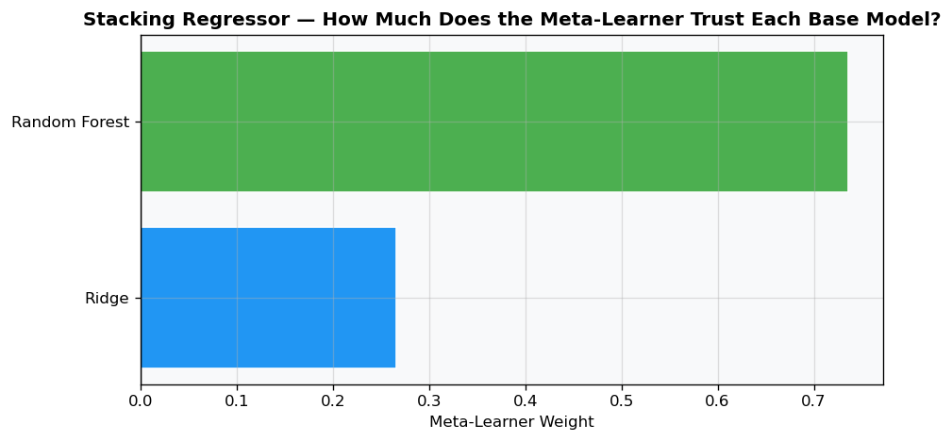
Figure 15 — Stacking Meta-Learner Weights

9. Comparative Analysis and Discussion
Paradigm | Best Model | Key Metric | Suitable When
Regression | Stacking Regressor | R² = 0.9608 | Detailed analytics, continuous risk scoring
Classification | Hist Gradient Boosting | Macro-F1 = 0.8679 | Operational traffic-light dashboards
Clustering | K-Means (K=4) | Silhouette: 0.3678 | Quality segmentation without survey data
Anomaly Detection | DBSCAN | Noise: 83.3% | Maximum-accuracy production deployment

Table 9 — Comparative Analysis Summary

Cross-paradigm analysis proves that while Regression preserves the granular nuance of individual sessions, Supervised Classification using Hist Gradient Boosting represents the most practical setup for operational alert frameworks. This selection is heavily justified by the feature space, where heavy impairments like buffer_ratio and packet_loss_pct operate as sharp, non-linear thresholds in human experience.
Unsupervised clustering confirmed that objective metrics naturally form distinct behavioral patterns, but its low label overlap metrics (ARI of 0.2342) prove that unsupervised models cannot serve as accurate primary gatekeepers. Thus, the classification paradigm balances operational needs best: it successfully handles extreme performance variations across different technologies (2G to 5G) while focusing predictive power directly on isolating high-risk user sessions.

10. Conclusion

What We Set Out to Do
This project built and analyzed a multi-paradigm machine learning framework designed to predict subjective user Quality of Experience (QoE) directly from automated, network-side Quality of Service (QoS) telemetry. By running the identical dataset across four separate analytical structures, we proved that selecting an optimal model depends entirely on how the underlying telecom monitoring question is framed.
Key Findings
- Impairment Dominance: Features tracking buffer_ratio and packet_loss_pct consistently dominate model splits and coefficients across all paradigms, confirming they are the primary drivers of user dissatisfaction.
- Paradigm Lead: Supervised classification using Hist Gradient Boosting delivers the most robust performance, achieving a peak Macro-F1 score of 0.8679 and an accuracy of 0.8428.
- Pragmatic Production Choices: Unsupervised frameworks function effectively as anomaly detectors rather than classic tier classifiers due to human perceptual variances. Furthermore, because ensemble methods yield minimal metric gains (Stacking $R^2$ of 0.9608 vs. Solo RF $R^2$ of 0.9605), single tree-based algorithms represent the most efficient option for real-world deployment.

Recommendation for a Cameroonian Telecom Operator
For an operator such as MTN Cameroon or Orange Cameroon, the recommended deployment strategy combines multiple paradigms: regression models embedded in network monitoring dashboards for continuous MOS estimation, classification-based alerting for rapid identification of Poor-tier sessions requiring intervention, and periodic unsupervised clustering of network logs to detect emerging quality segments without requiring new user surveys.
- Real-time monitoring: Deploy the Random Forest regression model to estimate MOS continuously from live QoS telemetry, enabling proactive network optimisation before users experience noticeable degradation.
- Alert thresholds: Use the classification model's Poor-tier predictions to trigger automatic network diagnostics or customer outreach for at-risk sessions.
- Quality segmentation: Run clustering periodically on aggregated cell-tower-level QoS logs to identify geographic or temporal zones of degraded service, informing infrastructure investment decisions.

References
[1] ITU-T Recommendation P.1203 (2017). Parametric bitstream-based quality assessment of progressive download and adaptive audiovisual streaming services over reliable transport. International Telecommunication Union.
[2] ITU-T Recommendation P.800 (1996). Methods for subjective determination of transmission quality. International Telecommunication Union.
[3] Hastie, T., Tibshirani, R., & Friedman, J. (2009). The Elements of Statistical Learning (2nd ed.). Springer.
[4] Müller, A. C., & Guido, S. (2016). Introduction to Machine Learning with Python. O'Reilly.
[5] [Add any other sources cited]

